How to create a Test

What is a test?
In Cerberus, a Test is meant to contain multiple Test Cases which test a specific feature.
For example, to test the Login function of an application you should create a Test named “Login”. The Test “Login” will contain multiple Test Cases testing the Login function of your application.

Create a Test
On the Homepage of Cerberus, click on the menu Test
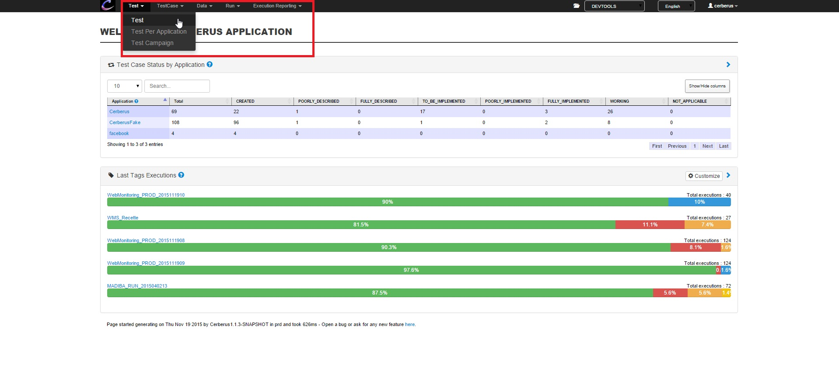

Here is displayed a list of all the Test already created.
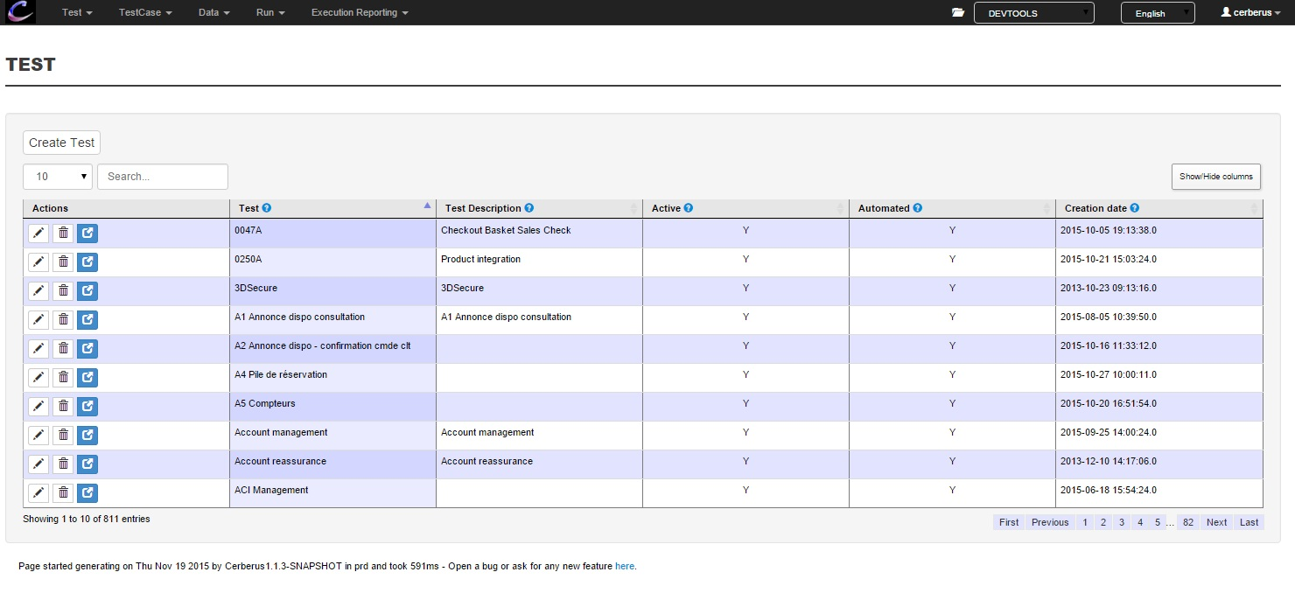
To create your Test, click on the button “Create Test”:
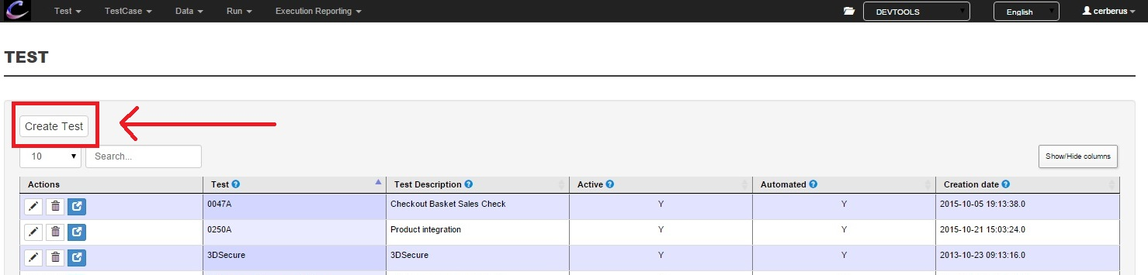
The following pop-in is displayed: 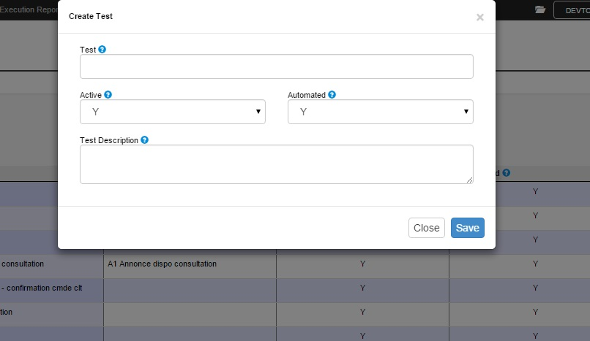

Description of the fields:
Test: This is the short name of your Test, this field is limited to 45 characters. The name of your Test should be specific to the feature you want to Test and concise.
Active: This field defines whether your Test is active or not.
If your Test is not active, you won’t be able to Run the Test Cases contained in this Test
Automated: This field defines whether your Test is automated or not.
If your Test is not automated, you will be able to Run the Test Cases contained in this Test only manually.
Test Description: This is the description of your Test.
Use it to add more details on what your Test is used for.
After you have filled all the fields, click on the save button to save your Test:
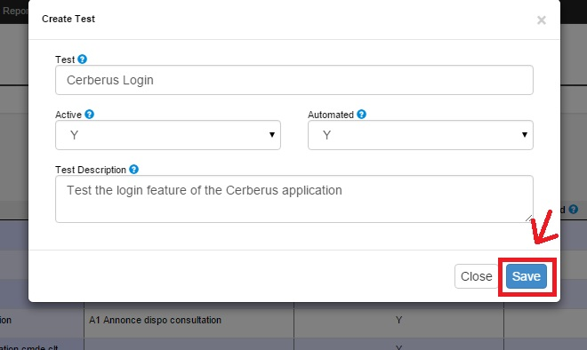
The Test you have just created should now be displayed on the list:
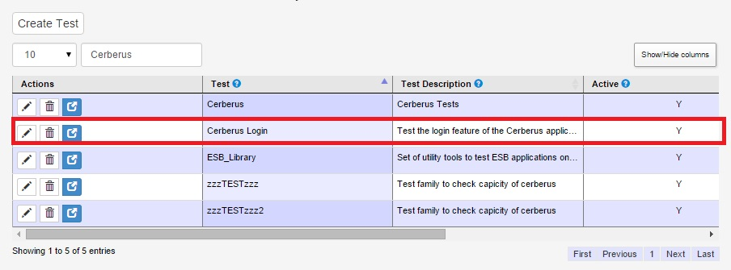
Specific actions:
: Use this button to Edit your Test. (If you have the rights to do it)
: Use this button to Delete your Test. (If you have the rights to do it)
: Link to the list of Test Cases related to this Test.

